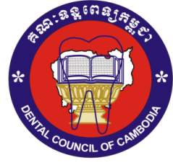
KINGDOM OF CAMBODIA NATION RELIGION KING
3

Dental Council of Cambodia
Flow Chart of Registration’s foreigner Dentist
Online Registration for Foreign Dentist
www.hpc-cambodia ( RMS )Registrant Management System
- Passport
- Visa Type E
- Current License from Own Country, Certified from Authorities in own Country
- Letter of Good Standing
- Certified of qualification(s) Certified from Authorities in own Country
- At least 5 Years Experiences in Dentistry
- Criminal Record from Own Country or Living Country.
- Working Latter from your work place in Cambodia
*** All submitted Document must be in Khmer or English
Applicant
Online Registration
www.hpc-cambodia

Dental Council Cambodia Verify, Decide and
Approve for Registration of
- Ministry of Foreign Affairs and International Cooperation (For Visa Type E).
- Ministry of Interior (For Immigration Acts)
- Ministry of Labour and Vocational Training (For Certificates of Employment in Cambodia)
- Ministry of Economy and Finance (For Taxes).

